**Online Charity Management System**

**A Synopsis**

**Submitted**

**In Partial Fulfillment of the Requirements for**

**The Degree of**

# Bachelor of Technology

**In**

**Computer Science**

**Submitted By (Name & Roll. No):**

**HIMANSHU SIKARWAR (2000320120085)**

**KAPIL PANWAR (2000320120093)**

**KUNAL SRIVASTVA (200320120099)**

**MRADUL PRATAP (200320120111)**

**Under the Supervision of:**

**Mrs. KALPANA**

**(Assistant Professor)**



**Department of Computer Science**

# CERTIFICATE

This is to certify that **Mr. Kapil Panwar** (Roll. No. 2000320120093) ha**s** carried out the work presented in the synopsis titled **“Charity Management Website”** submitted for partial fulfillment for the award of the **Bachelor of Technology In Computer Science** from **ABESEC, Ghaziabad** under my supervision.

It is also certified that:

1. This synopsis embodies the original work of the candidate and has not been earlier submitted elsewhere for the award of any degree/diploma/certificate.
2. The candidate has worked under my supervision for the prescribed period.
3. The synopsis fulfills the requirements of the norms and standards prescribed by the AKTU and ABESEC, Ghaziabad, India.
4. No published work (figure, data, table etc.) has been reproduced in the synopsis without express permission of the copyright owner(s).

Therefore, I deem this work fit and recommend for submission for the award of the aforesaid degree.

MrS. Kalpana Dr. Pankaj Sharma

Synopsis Guide (H.O.D) Department of CS Department of CS ABESEC, Ghaziabad ABESEC, Ghaziabad

Date: 21/09/2022

Place: Ghaziabad

# CERTIFICATE

This is to certify that **Mr. Himanshu Sikarwar** (Roll. No. 2000320120085) ha**s** carried out the work presented in the synopsis titled **“Charity Management Website”** submitted for partial fulfillment for the award of the **Bachelor of Technology In Computer Science** from **ABESEC, Ghaziabad** under my supervision.

It is also certified that:

1. This synopsis embodies the original work of the candidate and has not been earlier submitted elsewhere for the award of any degree/diploma/certificate.
2. The candidate has worked under my supervision for the prescribed period.
3. The synopsis fulfills the requirements of the norms and standards prescribed by the AKTU and ABESEC, Ghaziabad, India.
4. No published work (figure, data, table etc.) has been reproduced in the synopsis without express permission of the copyright owner(s).

Therefore, I deem this work fit and recommend for submission for the award of the aforesaid degree.

MrS. Kalpana Dr. Pankaj Sharma

Synopsis Guide (H.O.D) Department of CS Department of CS ABESEC, Ghaziabad ABESEC, Ghaziabad

Date: 21/09/2022

Place: Ghaziabad

# CERTIFICATE

This is to certify that **Mr. Mradul Pratap** (Roll. No. 2000320120111) ha**s** carried out the work presented in the synopsis titled **“Charity Management Website”** submitted for partial fulfillment for the award of the **Bachelor of Technology In Computer Science** from **ABESEC, Ghaziabad** under my supervision.

It is also certified that:

1. This synopsis embodies the original work of the candidate and has not been earlier submitted elsewhere for the award of any degree/diploma/certificate.
2. The candidate has worked under my supervision for the prescribed period.
3. The synopsis fulfills the requirements of the norms and standards prescribed by the AKTU and ABESEC, Ghaziabad, India.
4. No published work (figure, data, table etc.) has been reproduced in the synopsis without express permission of the copyright owner(s).

Therefore, I deem this work fit and recommend for submission for the award of the aforesaid degree.

MrS. Kalpana Dr. Pankaj Sharma

Synopsis Guide (H.O.D) Department of CS Department of CS ABESEC, Ghaziabad ABESEC, Ghaziabad

Date: 21/09/2022

Place: Ghaziabad

# CERTIFICATE

This is to certify that **Mr. Kunal Srivastva** (Roll. No. 2000320120099) ha**s** carried out the work presented in the synopsis titled **“Charity Management Website”** submitted for partial fulfillment for the award of the **Bachelor of Technology In Computer Science** from **ABESEC, Ghaziabad** under my supervision.

It is also certified that:

1. This synopsis embodies the original work of the candidate and has not been earlier submitted elsewhere for the award of any degree/diploma/certificate.
2. The candidate has worked under my supervision for the prescribed period.
3. The synopsis fulfills the requirements of the norms and standards prescribed by the AKTU and ABESEC, Ghaziabad, India.
4. No published work (figure, data, table etc.) has been reproduced in the synopsis without express permission of the copyright owner(s).

Therefore, I deem this work fit and recommend for submission for the award of the aforesaid degree.

MrS. Kalpana Dr. Pankaj Sharma

Synopsis Guide (H.O.D) Department of CS Department of CS ABESEC, Ghaziabad ABESEC, Ghaziabad

Date: 21/09/2022

Place: Ghaziabad

## DECLARATION

I hereby declare that the synopsis titled **“Charity Management Website”** is an authentic record of the research work carried out by me under the supervision of Mrs. Kalpana , Department of Computer Science, for the period from September, 2022-23 at ABESEC, GHAZIABAD. No part of this synopsis has been presented elsewhere for any other degree or diploma earlier.

I declare that I have faithfully acknowledged and referred to the works of other researchers wherever their published works have been cited in the synopsis. I further certify that I have not willfully taken other's work, para, text, data, results, tables, figures etc. reported in the journals, books, magazines, reports, synopsis, theses, etc., or available at web-sites without their permission, and have not included those in this B.Tech synopsis citing as my own work.

Date: 21/09/2022 Signature:

STUDENTS (NAME & ROLL.N0.) :-

HIMANSHU SIAKRWAR (2000320120085)

KAPIL PANWAR (2000320120093)

KUNAL SRIVASTVA (2000320120099)

MRADUL PRATAP (2000320120111)

## 

## TABLE OF CONTENTS

**Contents Page No.**

Title Page (i)

Certificate (ii)

Declaration (iii)

Table of Contents (iv)

Introduction (v)

Literature Survey (vii)

Methodology/Planning of Work (ix)

Data Flow Diagram (xi)

Facilities required for proposed work (xii)

Conclusion & Future work (xiii)

References (xiv)

# INTRODUCTION

A charity management system is a software/website solution for a non-profit organization. It manages the charitable donations and also the donor base. Such a system includes features such as electronic fund transfer, donation management, fundraising, donor management, and event management.

There are certain key features that these systems offer to non-profits:

• Easily track donations and donors.

• Send gift messages to donors.

• Set up recurring payment plans.

• Get reports on their donations.

**Why Online Charity Management System?**

A charity management system is a specialized software/website designed for organizations to automate the process of managing their donor relations, fundraising campaigns, and overall financial operations. It can also be used to create reports on how well an organization is meeting its goals.

These systems are designed to be user-friendly and flexible in order to serve the needs of various types of non-profits. Some features that are often included in these systems are databases for storing information about donors, volunteers, events, products, pledges etc., customizable reporting tools for generating customized reports on fundraising progress etc., online donation processing system for accepting cash donations etc.

These management systems have benefited non-profits in a variety of ways including making it easier for organizations to track their progress towards goals and save time by automating manual processes.

* Design and integrate an automated system to improve the services and decreased the time spent calls and searching for services offered in the donation.
* Configure a gateway system for online payment to enable individual’s ease of payment from their mobile devices.

Therefore, we propose to build a charity management system for the distribution of donations between charities, giving people the ability to notify about the surplus, and to inform about the poor who need help.

❖ Development of income resources (donation).

❖ Management and distribution of contributions to all the needy and low-income families.

❖ Optimum provision and utilization of operational, physical, and human resources.

❖ Organization and maintenance of facilities and family’s data to allow the ease of their access.

❖ Speeding up the practical procedures. Helping decision Makers in their strategic action plans.

**Web development technologies used:**

* Front -end (client-side) technologies
* Back-end (server-side) technologies
* HTML
* CSS
* SQL
* PHP
* Web development frameworks

# LITERATURE SURVEY

It appeared that important factors that make people to contribute to projects run by NGOs are small donations (many can afford it) and feeling of being a part (founder) of an important project. Joined contributions of a group focused on solving particular problem is a good example of utilizing so called social capital. It is also worth to notice that good atmosphere (fun, joy, concert) and even day of the week has an influence on number of participants and their will to contribute to projects presented during an event. Martin and Randal in describe an interesting experiment which statistically proved so called ‘Sunday effect’, where donations dropped to a donationbox in City Gallery Wellington, New Zealand were larger and more frequent on Sundays than on other days of the week. Observed donators’ a reason why many large-scale charity programs implement money collections during concerts and other outdoor events where participants can observe each other while donating. Charity help and money donations become an important and growing part of world economy.

While registered charitable donations, reported in the Giving USA 2007 survey, exceeded US$295 billions in year 2006, the total sum collected in 2007 grew to US$ 306 billion in 2007. It is worth to notice that majority of giving came from individuals while only 1.3% of donations was contributed from huge actions supported by media. An effective way to reach wide audience at low price is Internet. The interactive media provide tools for delivery textual and audio, visual content while visitors (participants) have the possibility to react instantly. The action performed by visitors to a charity collection sites may give donation via internet money transfer (e.g. or credit card payment). They may also do some work in distributing information about the charity program by sending a message to their friends. And finally the visitor, who register in charity collection web-site, may be informed about new charity programs when they start. Frequent web-site visitor is also a valuable donator, who may bring some funds to charity program.

The money may come from sold advertising space in the web-site. Such an approach is used in a service run by Polish Humanitarian Action (NGO): pajacyk.pl, where a daily return and click of a user brings small donation from sponsor advertised in the site. Reported money donated this way is enough to serve daily ca. 2000 hot meals for children in selected Polish schools. In this research we try to analyse reasons why people decide to help, distinguish the most preferred forms of donations in the Internet space and finally there is a proposal of an approach which assumes that support goes only to those projects which can be fully financed from declared donations.

The novelty of the approach is in the fact that declared donations are deducted from accounts only in case when total declared sum is higher or equal to required resources. The projects is validated against legal regulations which, in case of Poland, do not allow (with some exceptions) public/internet basking for money by individuals but such a collection may be run by NGOs, foundations etc. The paper is built of 5 sections. After introduction there is a collection of motivations and arguments for participation and avoiding charity actions found in literature review and on internet forums under articles related to charity issues.

**Already running Project:**

Atul Satija already build a charity management website called GiveIndia to serve the need of the non-profit sector. this website is build for charitable organizations to manage their donations and volunteers.

GiveIndia can help with updating databases, monitoring incoming donations, tracking volunteer hours and more.

In the recent years, Charities have been using technology to manage their organizations and improve their efficiency. Nowadays, a lot of charities are turning to a charity management software in order to make their jobs easier and more efficient. The number of charities who use these kinds of software has increased by 800% in the last ten years.

# METHODOLOGY/ PLANNING OF WORK

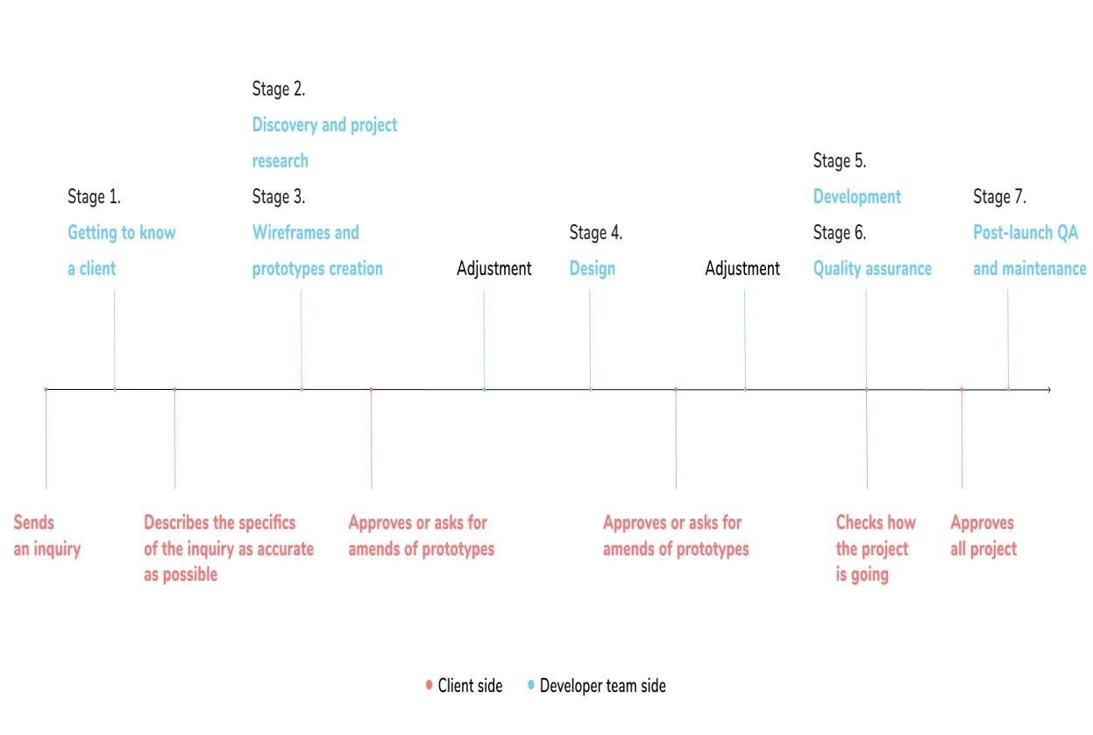

## Stage 1. Getting to know a client

After the company gets a message from a client that he or she wants to work with the developers' team, a project manager (PM from here) and a client’s representative discuss the client’s needs (or the specifications if clients already know what they want).

## Stage 2. Discovery and project research

Discovery means that the development team only investigates client’s business requirements and decide for themselves whether they can really solve a client’s problem. An outcome is getting to know a client's goal, business specifics, and initial requests.

## Stage 3. Wireframes and prototypes creation

Following is the work on the wireframes and prototypes in collaboration with the client and the team’s designer.

## Stage 4. Design

Working on design comps until final approval. The company carefully asks for all the details about the impression a client’s project should create.

## Stage 5. Development

Initial installation and configuration go first. Then developers set up all necessary settings of modules. They make sure every website page was approved, and the client has gone through demo versions of every feature on the website. It was a little hint from the development side to the client: check and test all the options. There are no minor ones when it comes to website usage. Believe us, your website’s visitors will notice every teeny-tiny bug.

## Stage 6. Quality assurance

Remember the hint from stage 5? Never ever omit the testing stage. After the integration test, we move to the functional and UI tests and end up with manual tests.

# 

# 

# 

# DATA FLOW DIAGRAM

PHP is a server-side scripting language that is used to develop Static websites or Dynamic websites or Web applications. It is designed for web development to implement dynamic web pages and can be embedded into HTML for it to be displayed. This Figure how the web server operates.

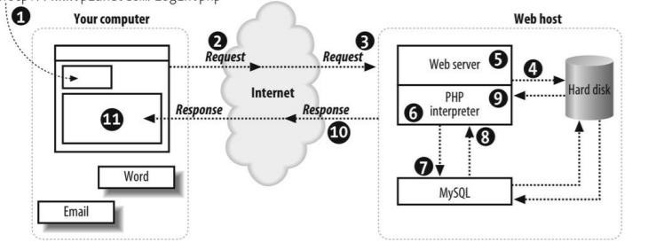

MySQL is a free source database system, and it enables the cost-effective delivery of reliable and a high-performance and scalable Web-based and embedded database applications. It is a relational database system. It is a high performing program and scalable to meet the demands of users and data. MySQL is written in C and C++, so it is compatible with most of the operating systems available around the world.

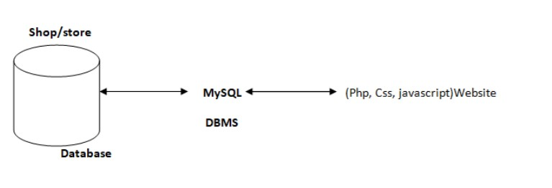

## FACILITIES REQUIRED FOR PROPOSED WORK

• **Software and hardware are requirements:**

* Operating System: WINDOWS 10
* Web Server: XAMPP Server
* IDE: Visual Studio Code
* RAM: 8 GB RAM
* Processor: intel Core i3 processor (at least)
* Hard Disk: 1Tb (at least)

# 

**Conclusion & Future Work**

Help directly. Donors shy away from spending on overhead and they may overestimate what portion of their donations goes toward fundraising and salaries (Bennett 2002). Charities can try to convince donors that their donations will help people directly by guaranteeing that their specific donations will not pay for overhead. They can also give donors the power to choose which cause their donation supports, which may increase donors’ confidence in the impact of their gift. Make a meaningful contribution to solving a problem. Donors tend to avoid contributing to needs that are large in scope, or that will last a long time. They like giving to charitable campaigns that are very close to succeeding already. But even if a charity is dealing with a difficult long-term issue that affects millions of people, they could still benefit by offering “small victories” to their donors. Charities should always give donors the option (but not the obligation) to publicize their giving, as well as the ability to share news of their gift on social media. Publicizing donations could also help charities convince future donors to give more. Feel good about giving. Donors told that giving will make them happier sometimes give more than those told about the benefits their gift will have on other people. Donors also claim to be willing to give more when they receive feedback from charities on the impact of their giving. Charities should ensure that donors understand what good their donations have enabled, and might also benefit by encouraging donors to feel good about their generous actions. Effective charities could take advantage of their detailed impact measurement by sending especially detailed thank-you notes. On the other hand, charities should be careful not to provide potential donors with external motivation to give; this could actually reduce contributions, by leading people to think of a charitable interaction as a transaction rather than a gift.

* WE can give more advance software for Charity Management system including more facilities.

* Create the master and slave database structure to reduce the overload of the database queries.

* Implementing the backup mechanism for taking backup of codebase and database on regular basis on different servers.

**REFERENCES**

* + - [**https://www.w3schools.com/**](https://www.w3schools.com/)
    - [**https://www.geeksforgeeks.org/**](https://www.geeksforgeeks.org/)
    - [**https://www.javatpoint.com/**](https://www.javatpoint.com/)
    - [**https://www.youtube.com/**](https://www.youtube.com/)
    - [**https://www.google.co.in/**](https://www.google.co.in/)
    - [**https://trainings.internshala.com/**](https://trainings.internshala.com/)